**IC3203 :: MEASUREMENT SYSTEMS**

**Course Prerequisites:** Knowledge of basic physics, electronics and electrical engineering.

**Course Objectives:**

1. To get knowledge of various electrical and electronic instruments and their applications
2. To understand various type electromagnetic interferences and their reduction techniques
3. To  understand the concepts of reliability and methods to improve a system  reliability
4. To understand various analytical instruments and their measurement techniques
5. To understand the operation and applications of various biomedical instruments

**Credits: 5                                                                    Teaching Scheme Theory: 3** Hours/Week

**Tut  : 1** Hour/Week

**Lab :** **2** Hours/Week

**Course Relevance:** This course is one of the important core subjects of instrumentation engineering. It deals with the study of various electronics analytical and biomedical instruments which are extensively used in various industries and laboratories, for testing electrical and electronics equipments systems necessary for various applications in industries

|  |
| --- |
| **SECTION-1** |
| **Electrical and Electronic Measuring Instruments:** Analog instruments such as PMMC and moving iron type AC / DC voltmeter and ammeter. Digital multimeter (DMM) construction, measurement techniques, specifications and applications. Introduction to cathode ray oscilloscope CRO, digital storage oscilloscope (DSO), operating modes, sampling techniques, specifications and applications. Instruments for waveform analysis such as distortion meter and spectrum analyzer. Insulation testers and LCR meters. Timers / counters techniques, operating modes, specifications and applications. ATE types, testing techniques and applications.  **Electromagnetic Interference and Electromagnetic Compatibility:** EMI/EMC, intrinsic and extrinsic noise, effects on instruments and minimization technique. ESD, causes, Human ESD model, minimization techniques H/W and S/W protection against ESD.  **Reliability Engineering:** Introduction to reliability of systems. Bathtub curve.  Various causes of failure. Techniques for improvement of reliability. Redundancy techniques. |
| **SECTION-2** |
| **Analytical Instruments and Measurement:** Introduction and classification of analytical instruments, qualitative and quantitative analysis.Electromagnetic spectrum, beer lamberts law, optical filters and monochromators. Filter photometer, colorimeter and spectrophotometers. Gas analyzers. Gas and liquid chromatography instruments. Measurement of  PH, viscosity, conductivity, humidity and turbidity.  **Biomedical Instrumentation:**  Introduction to human physiology, Biopotential generation, sensors used for physiological measurement Cardiovascular system and related instruments      (Blood pressure measurement, ECG recorder, Blood flow measurement, blood volume measurement). Life saving devices like pacemaker, defibrillator, heart lung system. Brain system and EEG recorder. Respiratory system and spirometers ,  IOT in Biomedical system. |
|  |
| **List of Tutorials: (Any Three)**   1. Digital multimeter circuits 2. Extension of analog voltmeter and ammeter ranges 3. Measurement of intrinsic noise in electronic components. 4. Testing using ATE systems 5. Calculation of reliability of a system. 6. Measurement of concentration using a filter photometer. 7. Sensors requirement for physiological measurement 8. Cardiovascular signal processing techniques 9. Spirometer measurement techniques 10. IOT in healthcare system |
|  |
| **List of Practicals: (Any Six)**   1. Conversion of a galvanometer into a voltmeter and ammeter 2. Electronics components testing using a DMM 3. Demonstration of  the operation of a digital storage oscilloscope. 4. Measurement of waveform distortion using a distortion meter 5. Insulation measurement using an insulation tester. 6. Frequency and time period measurement using an universal counter. 7. Quantitative analysis using a filter photometer or a spectrophotometer. 8. Blood pressure measurement using VI lab 9. ECG and EEG amplifier design 10. ECG and EEG filter design using |
|  |
| **List of Projects:**   1. Design a voltmeter or an ammeter using a galvanometer 2. Design of a digital voltmeter or ammeter 3. Design of a temperature measurement system 4. Design of  pressure measurement system 5. Design of humidity measurement system 6. Design of  a simple capacitance meter 7. PCB design for a given circuit 8. Design of a frequency counter 9. Design of an instrument for a given parameter measurement 10. Body temperature measurement system 11. PH measurement system 12. Measurement system for magnetic field strength measurement |
| **List of Course Seminar Topics:**   1. Applications of automatic test equipments 2. Redundancy techniques in various equipments 3. Calculation of MTTF and MTBF of a system. 4. DSO specifications and selection 5. Virtual instruments 6. PCB making process 7. EMI testing techniques 8. Shielding and grounding techniques. 9. Surface mount devices SMD 10. Smart energy meter 11. Lux meter 12. Gauss meter |
| **List of Course Group Discussion Topics:**   1. Selection of electronic instruments for waveform analysis 2. Design of an analog to digital converter 3. Design of an analog to digital converter 4. Problems in healthcare system and implementation 5. IOT implementation in biomedical system 6. Virtual training in Biomedical systems 7. Opportunities in biomedical system 8. Milliohm and micro ohm measurement techniques. 9. Weather parameter measurement and monitoring 10. Selection of electronic instruments for various electrical parameters |
| **List of Home Assignments:**  **Design:**   1. Design of a DMM circuit. 2. IOT in measurement systems. 3. Various static and dynamic characteristics of measuring instruments. 4. Atomic absorption spectroscopy and applications 5. Design of a measurement system for a given parameter   .  **Case Study:**   1. Testing of SMPS for electromagnetic interference 2. IOT for biomedical applications 3. Applications of a spectrophotometer in a pathology lab. 4. Vehicle pollution measurement technique 5. Instruments in flight   **Blog**   1. Analog to digital converter techniques 2. Digital to analog converter techniques 3. True RMS multimeters 4. Flame photometer and applications 5. Spirometer   **Surveys**   1. IOT based measuring instruments 2. Various applications of a spectrophotometer 3. Types of oscilloscopes 4. ATE application in electronic industries 5. Virtual instruments |
| **Assessment Scheme:** Course Assessment:   Total : 100 mks  1.  Mid Semester Examination   : 15 marks (Total : 30 marks based on Section I)  *30 marks converted to 15*  2. End Semester Examination: 15 marks (Total : 30 marks based on on Section II)  *30 marks converted to 15*  3. Lab Assessment: Lab Assignments - 10 marks (6 assignments-10 marks each)                                                                (*60 marks converted to 12)*  4. Course Project : 10 marks (*40 marks converted to 8)*  5.  Home Assignment : 10 mks (Total : 100 marks: Case study, Design work, Survey, Blog)  *100 marks converted to 10*  6. Viva  : 20 mks (at the end of semester); *100 marks converted to 20*  7. Seminar  : 10 mks (at the end semester); *100 marks converted to 10*  8. Group Discussion: 10 mks (at the Mid of semester); *100 marks converted to 10* |
|  |
| **Text Books:** |
| 1.  [Kalsi H S](https://www.google.co.in/search?tbo=p&tbm=bks&q=inauthor:%22Kalsi+H+S%22);  Electronic Instrumentation; Tata McGraw-Hill.  2.  A. J. Bowens; Digital Instrumentation; Tata McGraw-Hill.  3. Reliability  3. R S Khandpur; Handbook of Analytical Instruments; McGraw Hill Education; 2 edition  4. Willard, H. H., Merritt Jr, L. L., Dean, J. A., & Settle Jr, F. A.  Instrumental methods of analysis. 7th edition. CBS Publishers & Distributors.  5. [R.S. Khandpur](https://www.goodreads.com/author/show/2815598.R_S_Khandpur); Handbook of Biomedical Instrumentation; Third Edition; 2014, McGraw Hill Education (India) Private Limited. |
|  |
| **Reference Books:** |
| 1. Sawhney, A. K;  Electrical and electronic Measurements and Instrumentation. Dhanpar Rai and  Sons.  2. [Ananda R. N](https://www.amazon.in/s/ref=dp_byline_sr_ebooks_1?ie=UTF8&field-author=ANANDA++R.+NATARAJAN&text=ANANDA++R.+NATARAJAN&sort=relevancerank&search-alias=digital-text)atarajan;  Biomedical Instrumentation and Measurements;  PHI Learning. |
|  |
| **Moocs Links and additional reading material:** [www.nptelvideos.in](http://www.nptelvideos.in)  <http://www.nptelvideos.in/2012/11/industrial-instrumentation.html> |
| **Course Outcomes: After completing the course the students will be able to**   1. Demonstrate the operation of various electronic instruments 2. Select an electronic instrument for a given application 3. Contribute in the design or development of a measurement system 4. Select and use analytical instrument for measuring chemical parameters 5. Understand and demonstrate the operation of various biomedical instruments |
| **CO PO Map**   |  |  |  |  |  |  |  |  |  |  |  |  |  |  |  |  | | --- | --- | --- | --- | --- | --- | --- | --- | --- | --- | --- | --- | --- | --- | --- | --- | | **CO** | **PO-1** | **PO-2** | **PO-3** | **PO-4** | **PO-5** | **PO-6** | **PO-7** | **PO-8** | **PO-9** | **PO-10** | **PO-11** | **PO-12** | **PSO-1** | **PSO-2** | **PSO-3** | | **1** | 2 | 2 | 1 | 1 | 1 | 1 | 1 | 0 | 0 | 0 | 1 | 1 | 2 | 2 | 2 | | **2** | 2 | 3 | 1 | 1 | 1 | 1 | 1 | 0 | 0 | 0 | 1 | 1 | 2 | 2 | 2 | | **3** | 2 | 3 | 1 | 1 | 1 | 1 | 1 | 0 | 0 | 0 | 1 | 1 | 3 | 3 | 3 | | **4** | 2 | 2 | 1 | 1 | 1 | 1 | 1 | 0 | 0 | 0 | 1 | 1 | 2 | 1 | 1 | | **5** | 2 | 2 | 1 | 1 | 1 | 1 | 1 | 0 | 0 | 0 | 1 | 1 | 1 | 1 | 1 | |
| **CO attainment levels**   |  |  |  |  |  |  | | --- | --- | --- | --- | --- | --- | | **CO No.** | **IC3203_CO1** | **IC3203_CO2** | **IC3203_CO3** | **IC3203_CO4** | **IC3203_CO5** | | **Attainment Level** | 2 | 3 | 5 | 4 | 3 | |
| **Future Courses Mapping:** |
| **Job Mapping:**  *Electronic instruments manufacturing industries. Electronic testing labs. Biomedical and analytical instruments manufacturing industries and  services. Electronic industries.*  *Electrical equipment manufacturing industries.* |

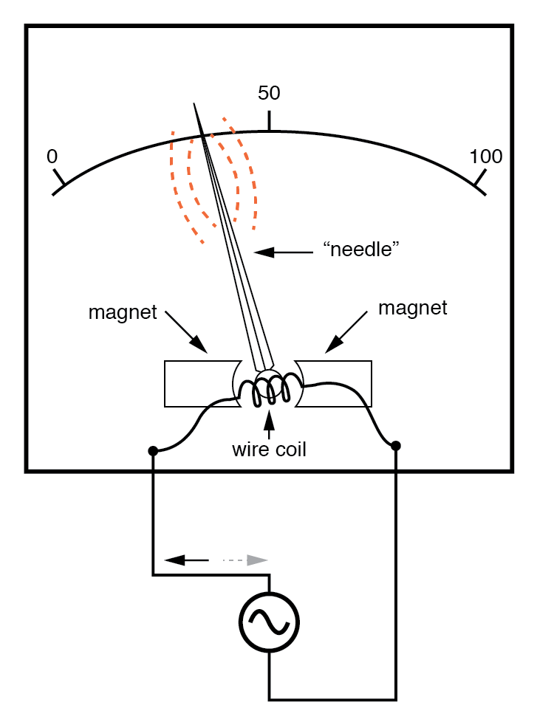

Passing AC through this D’Arsonval meter movement causes useless flutter of the needle.

In order to use a DC-style meter movement such as the D’Arsonval design, the alternating current must be rectified into DC.

This is most easily accomplished through the use of devices called [*diodes*](https://www.allaboutcircuits.com/textbook/semiconductors/chpt-3/introduction-to-diodes-and-rectifiers/). We saw diodes used in an example circuit demonstrating the creation of harmonic frequencies from a distorted (or rectified) sine wave. Without going into elaborate detail over how and why diodes work as they do, just remember that they each act like a one-way valve for current to flow.

The arrowhead in each diode symbol points in the permitted direction of current flow.

Arranged in a bridge, four diodes will serve to steer AC through the meter movement in a constant direction throughout all portions of the AC cycle:

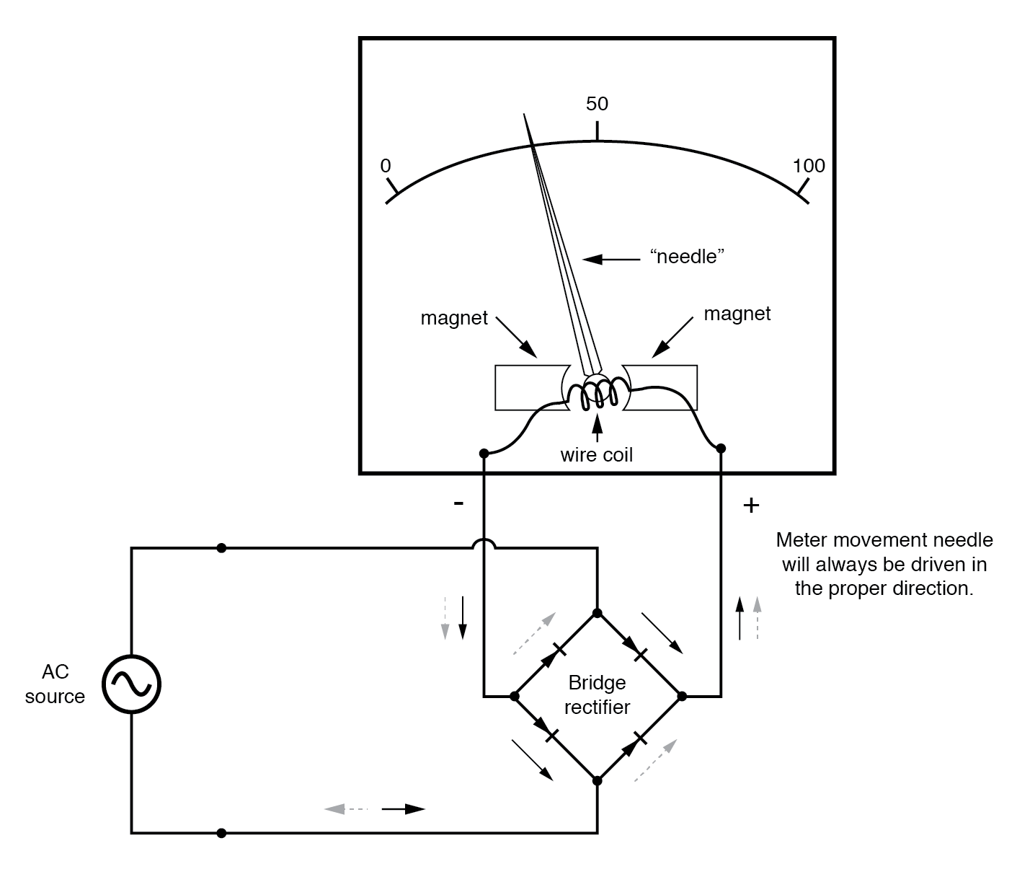

Passing AC through this Rectified AC meter movement will drive it in one direction.

Another strategy for a practical AC meter movement is to redesign the movement without the inherent polarity sensitivity of the DC types.

This means avoiding the use of permanent magnets. Probably the simplest desig

ttps://www.allaboutcircuits.com/textbook/alternating-current/chpt-12/ac-voltmeters-ammeters/